# **MongoDB Tasks**

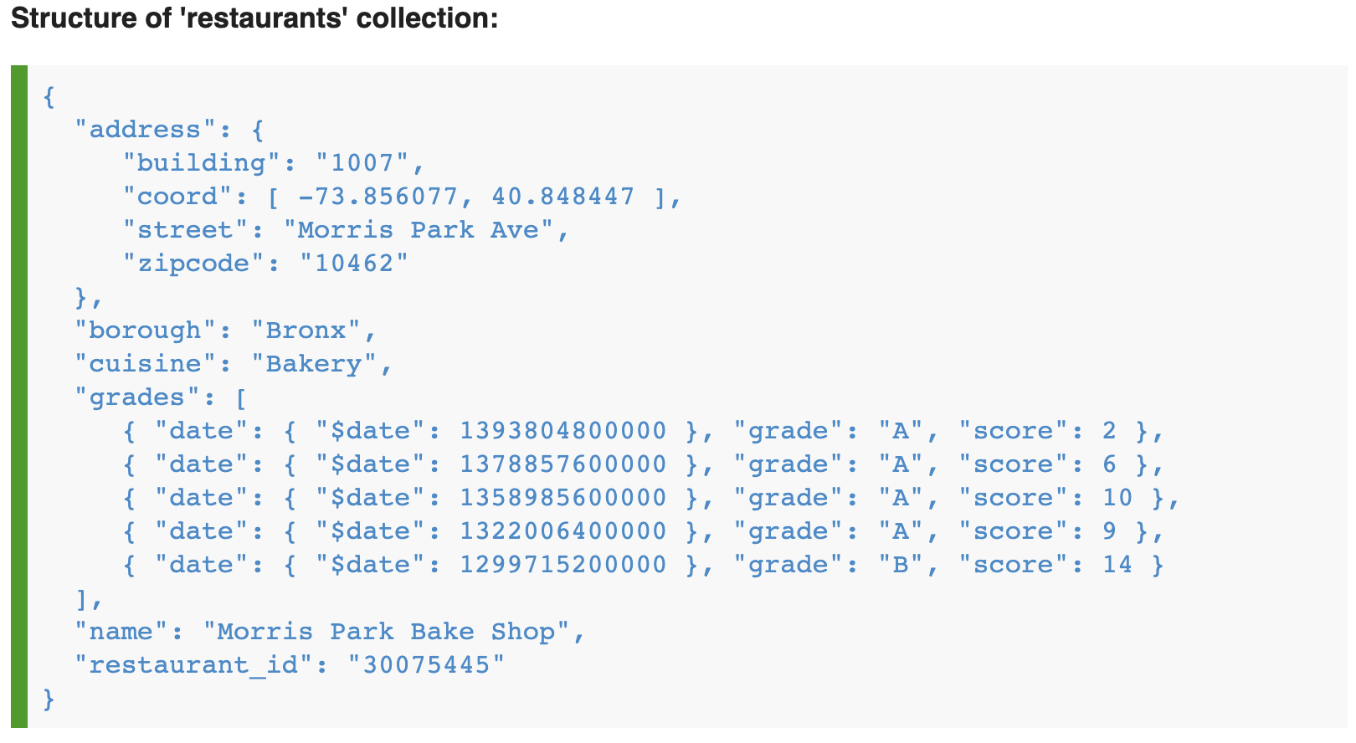

1. Write a MongoDB query to display all the documents in the collection restaurants
2. Write a MongoDB query to display the fields restaurant_id, name, borough and cuisine for all the documents in the collection restaurant
3. Write a MongoDB query to display the fields restaurant_id, name, borough and cuisine, but exclude the field _id for all the documents in the collection restaurant.
4. Write a MongoDB query to display the fields restaurant_id, name, borough and zip code, but exclude the field _id for all the documents in the collection restaurant
5. Write a MongoDB query to display all the restaurant which is in the borough Bronx
6. Write a MongoDB query to display the first 5 restaurant which is in the borough Bronx.
7. Write a MongoDB query to find the restaurants who achieved a score more than 90
8. Write a MongoDB query to find the restaurants that achieved a score, more than 80 but less than 100
9. Write a MongoDB query to find the restaurants which locate in latitude value less than -95.754168
10. Write a MongoDB query to find the restaurants that do not prepare any cuisine of 'American' and their grade score more than 70 and latitude less than -65.754168
11. Write a MongoDB query to find the restaurants which do not prepare any cuisine of 'American' and achieved a score more than 70 and located in the longitude less than -65.754168.

Note : Do this query without using $and operator

1. Write a MongoDB query to find the restaurants which do not prepare any cuisine of 'American ' and achieved a grade point 'A' not belongs to the borough Brooklyn. The document must be displayed according to the cuisine in descending order
2. Write a MongoDB query to find the restaurants which belong to the borough Bronx and prepared either American or Chinese dish.
3. Write a MongoDB query to find the restaurant Id, name, borough and cuisine for those restaurants which belong to the borough *Staten Island* or *Queens* or *Bronx* or *Brooklyn*
4. Write a MongoDB query to find the restaurant Id, name, borough and cuisine for those restaurants which are not belonging to the borough Staten Island or Queens or Bronxor Brooklyn
5. Write a MongoDB query to find the restaurant Id, name, borough and cuisine for those restaurants which achieved a score which is not more than 10
6. Write a MongoDB query to find the restaurant Id, name, address and geographical location for those restaurants where 2nd element of coord array contains a value which is more than 42 and upto 52
7. Write a MongoDB query to arrange the name of the restaurants in ascending order along with all the columns
8. Write a MongoDB query to arrange the name of the restaurants in descending along with all the columns.
9. Write a MongoDB query to arranged the name of the cuisine in ascending order and for that same cuisine borough should be in descending order.
10. Write a MongoDB query to know whether all the addresses contains the street or not.
11. Add 2 new documents about restaurants in the collection
12. Delete 2 new documents about restaurants in collection
13. Write a MongoDB query to update the restaurants which do prepare cuisine of 'Hamburgers' in the borough “Brooklyn”, and change the zipcode to 'secret'.
14. Add new field ‘stars’ to the all documents in the collection
15. Write a MongoDB query to update the restaurants which do prepare cuisine 'Irish' and achieved a grade point 'A', and increase stars by 2
16. Write a MongoDB query to update the restaurants that do not prepare any cuisine of 'American' and their grade score more than 70 and latitude less than -65.754168 and add your own grade to the grades array  
    For date use function Date(). For example "date":Date(2022-06-14)  
    The structure of grade is:  
    data: Date(),  
    grade: <one letter>  
    score: <int>
17. Remove all grades where grade point is ‘Z’ in all documents.
18. Delete documents where prepare any cuisine of "Jewish/Kosher"
19. Remove all documents